**Cloud Computing Assignment 2 Jenkins**

Name: Naren Chandrashekhar

SRN: PES2UG20CS216

Section: D

**Task 1**

1. Screenshot of the running Docker Container after installing Jenkins

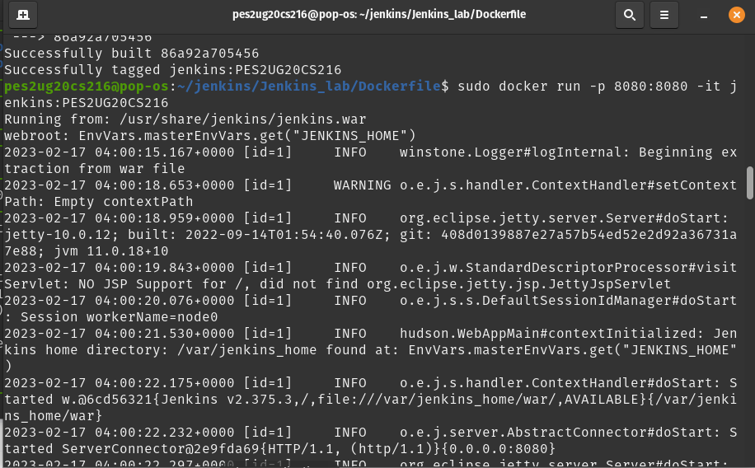

**Task2**

1. Picture showing the console output after the build is successful

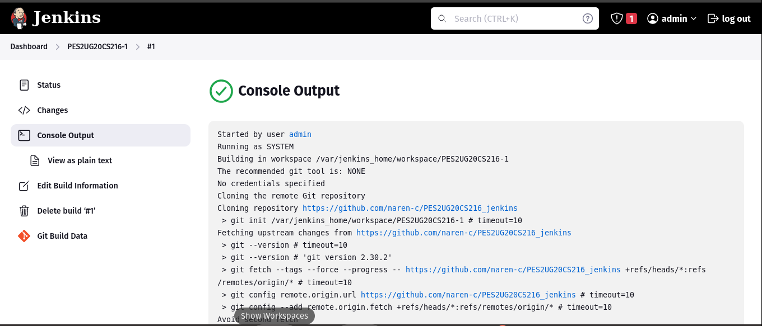

1. Picture showing the Stable state of the task in Build History of Jenkins

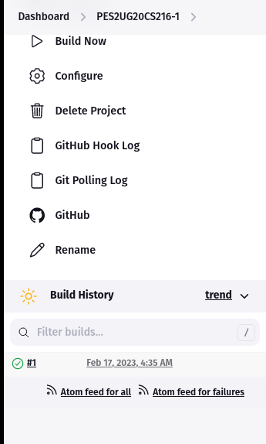

**Task 3**

1. Console output of second job

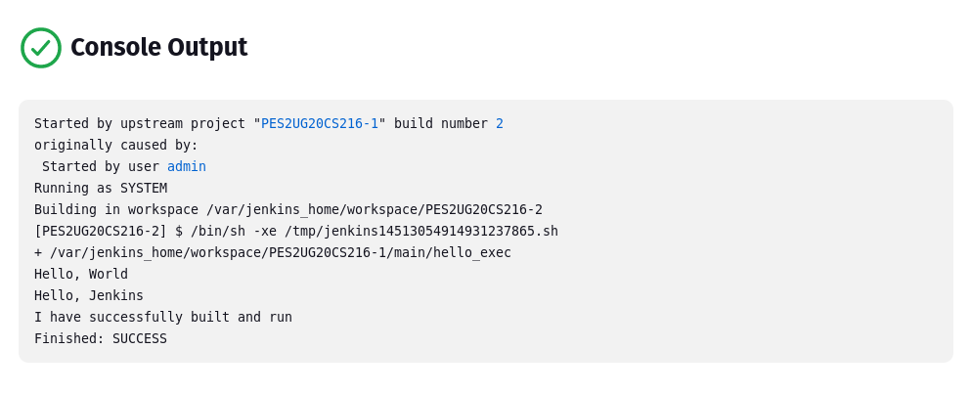

1. Status page of first job

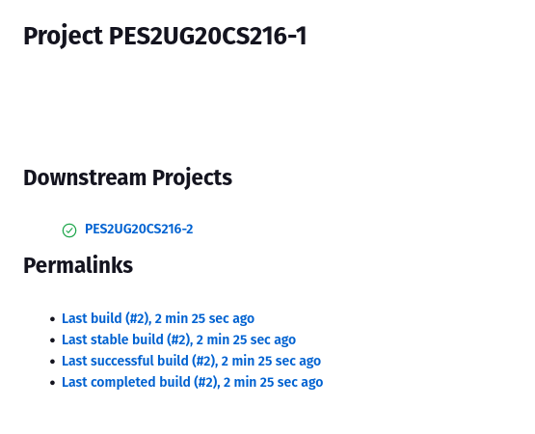

1. Build History of Jenkins

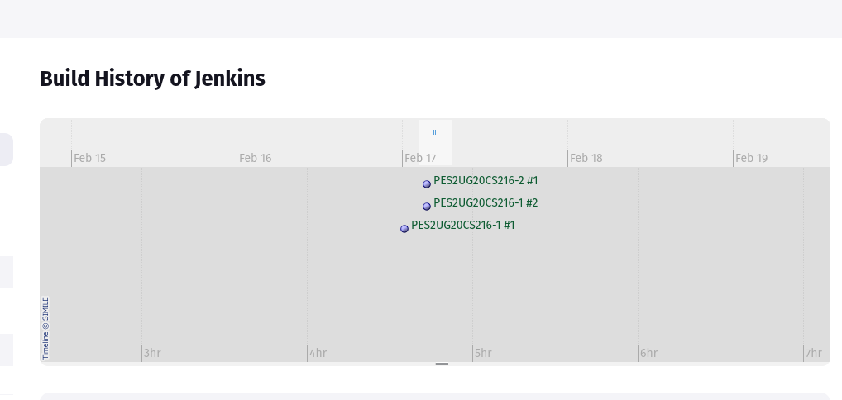

1. Jenkins Dashboard

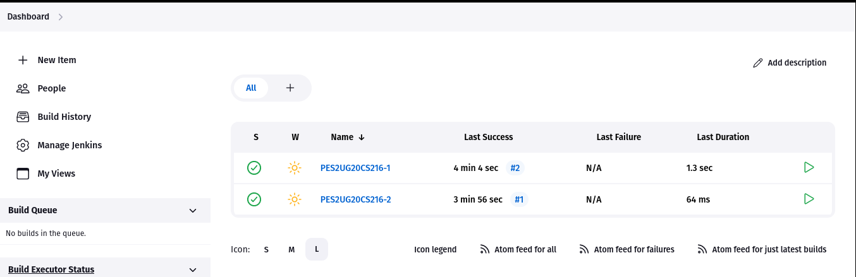

**Task 4**

1. Webhook added to your GitHub repository

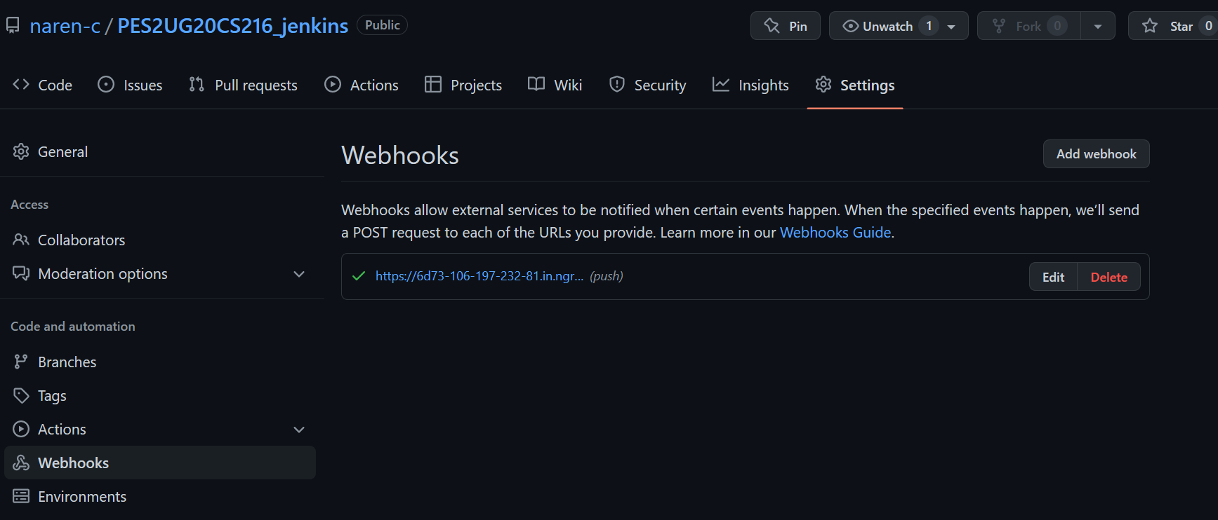

2. Console Output of second job displaying the change made in hello.cpp file.

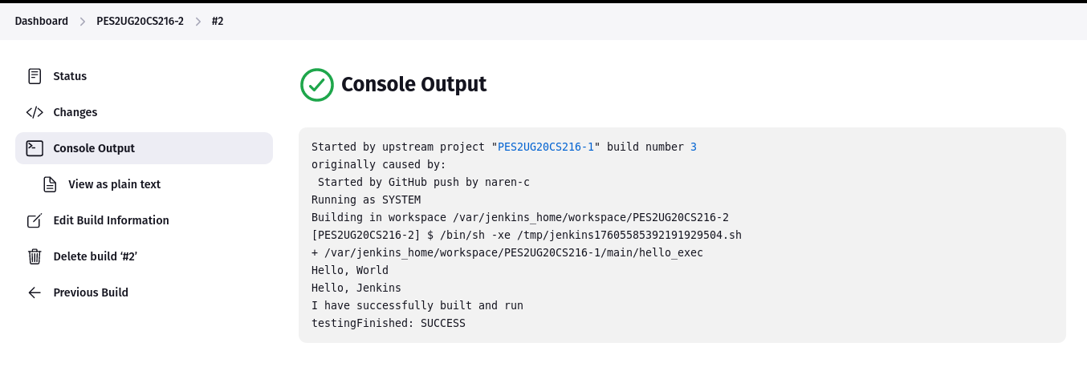

**Task 5**

1. Code/script written to create basic pipeline using GitHub repository

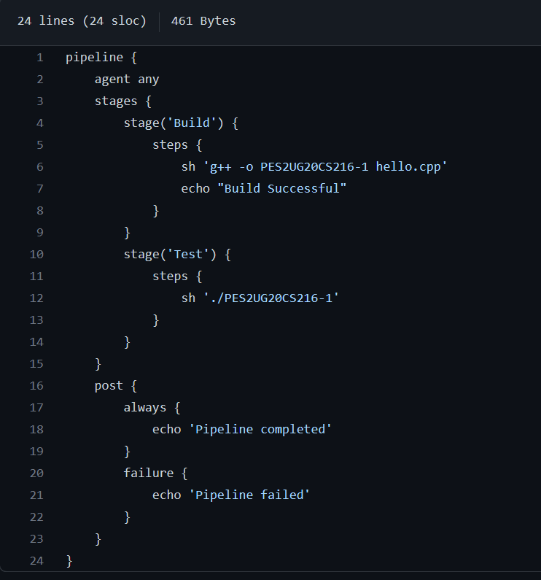

1. Output of working created pipeline, the screenshot should include

● Stage view / Execution status of pipeline with all stages succeeded

● Verify Declarative: Post Actions stage succeed for handling failures.

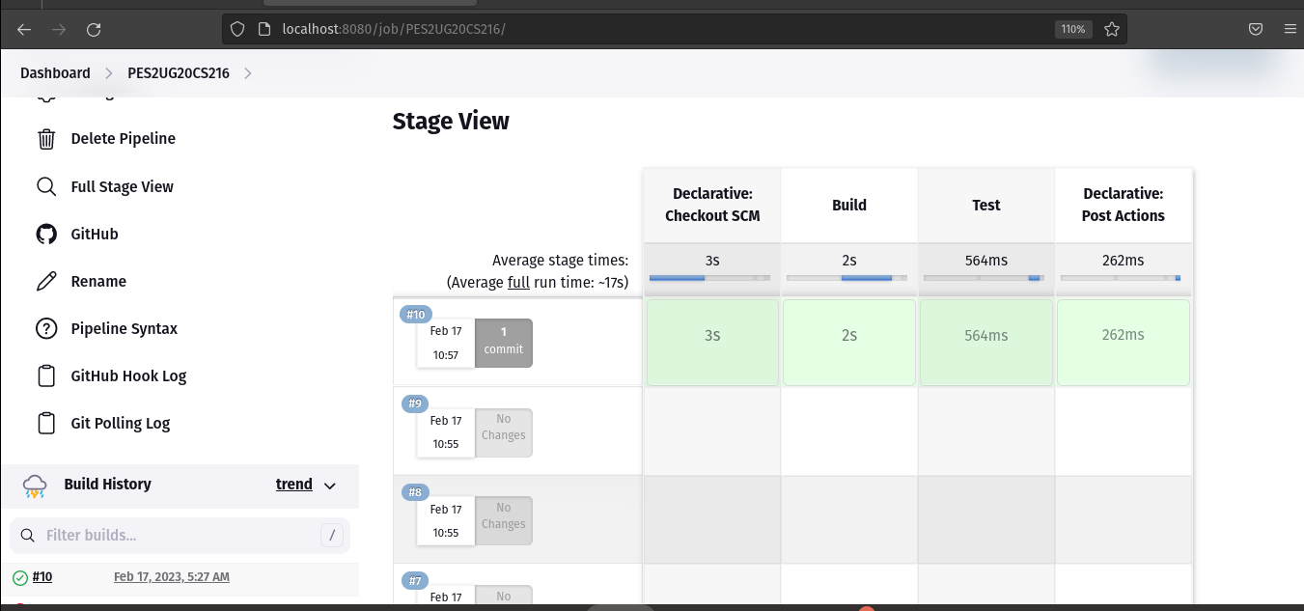

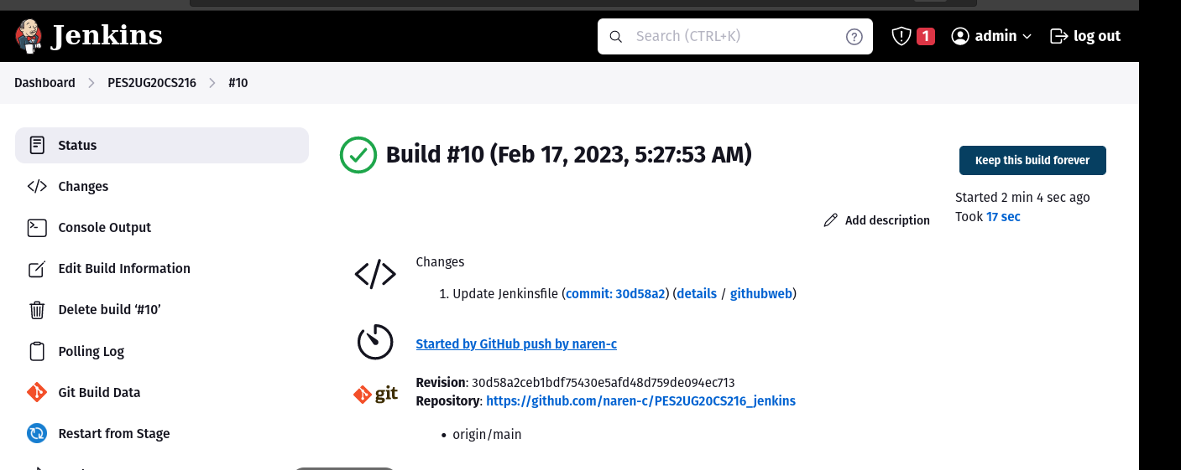

1. Console Output of the Pipeline

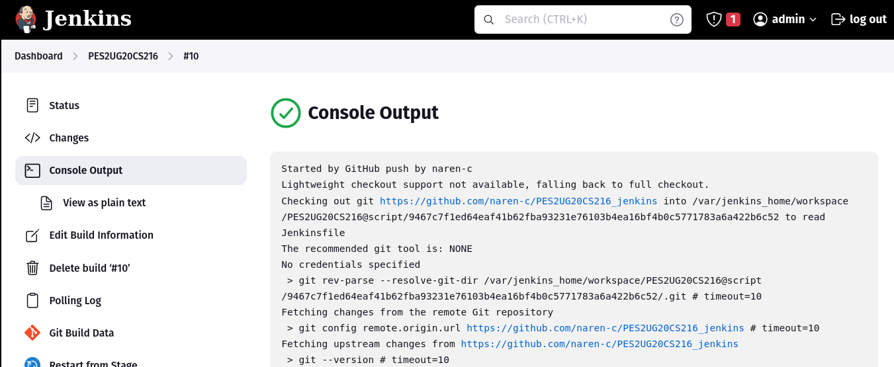

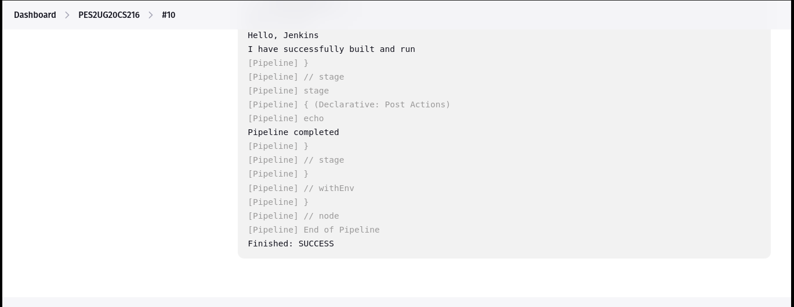

Now edit your Jenkinsfile, make an intentional error in one of the stages and commit. Execute the pipeline again, check if the expected stage fails and declarative post action “pipeline failed” carried out successfully

1. Output of working created pipeline, the screenshot should include

● Stage view / Execution status of pipeline with all stages succeeded

● Verify Declarative: Post Actions stage succeed for handling failures.

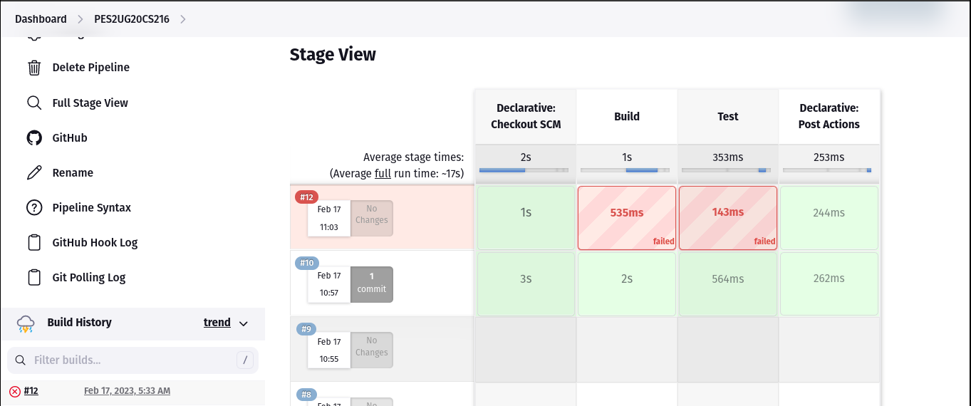

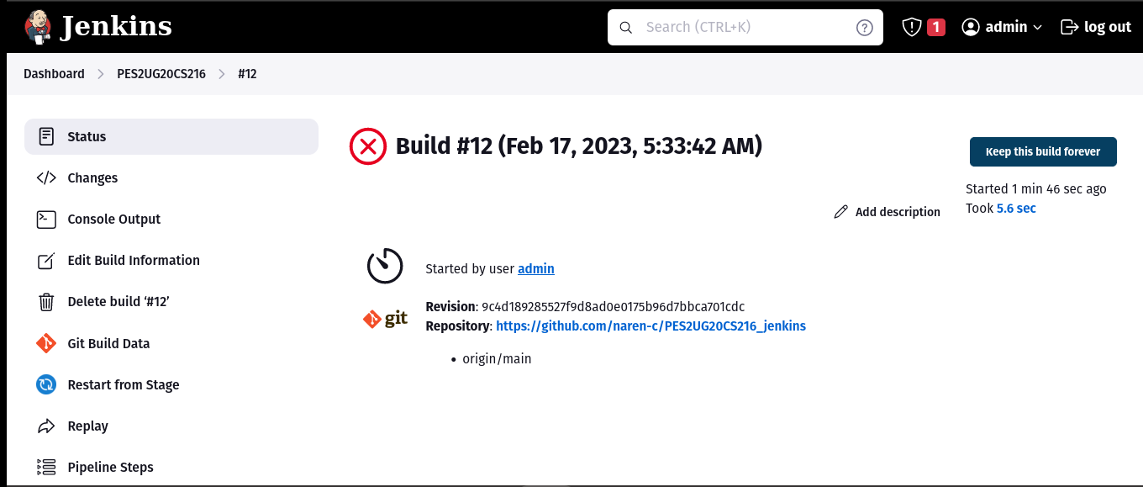

1. Console Output of the Pipeline

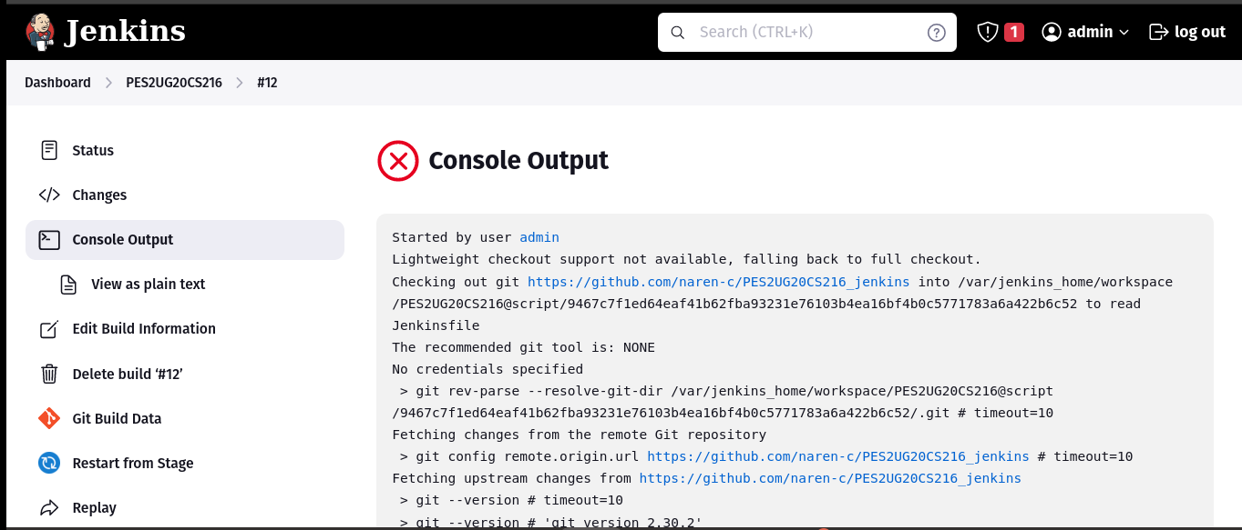

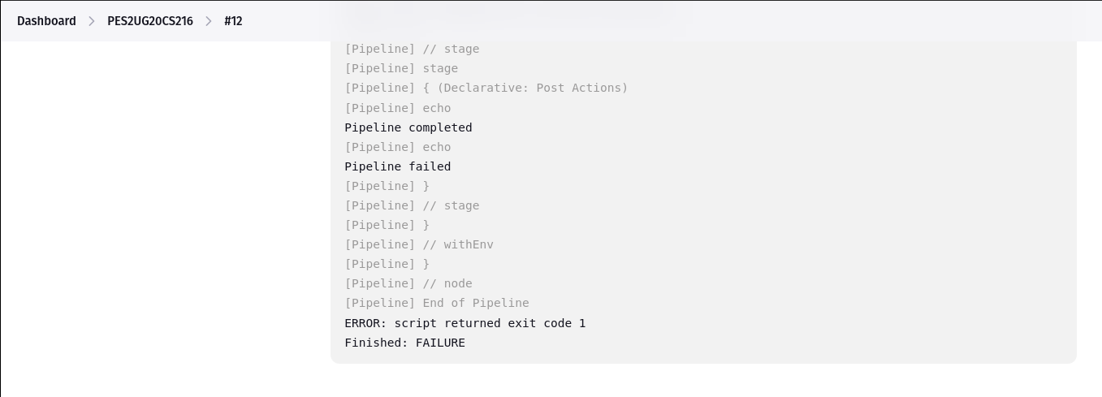

1. Link to the repository

[naren-c/PES2UG20CS216_jenkins (github.com)](https://github.com/naren-c/PES2UG20CS216_jenkins)